Week 11 Lecture 1

Previous Lecture
- Queue

Today’s Lecture
- Stack & Queue by linked lists

Recall Definition of Stack

- Logical (or ADT) level: A stack is an ordered group of homogeneous items (elements), in which the removal and addition of stack items can take place only at the top of the stack.

- A stack is a LIFO “last in, first out” structure.

Stack ADT Operations

- MakeEmpty -- Sets stack to an empty state.
- IsEmpty -- Determines whether the stack is currently empty.
- IsFull -- Determines whether the stack is currently full.
- Push (ItemType newItem) -- Adds newItem to the top of the stack.

- Pop (ItemType& item) -- Removes the item at the top of the stack and returns it in item.
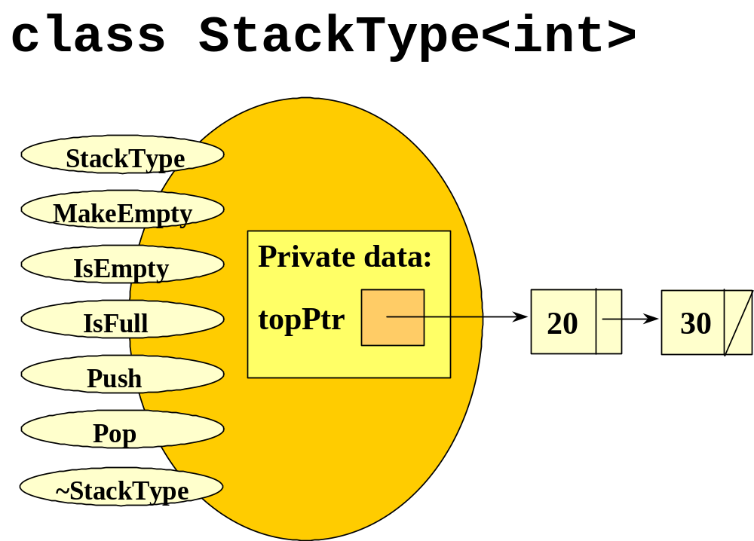
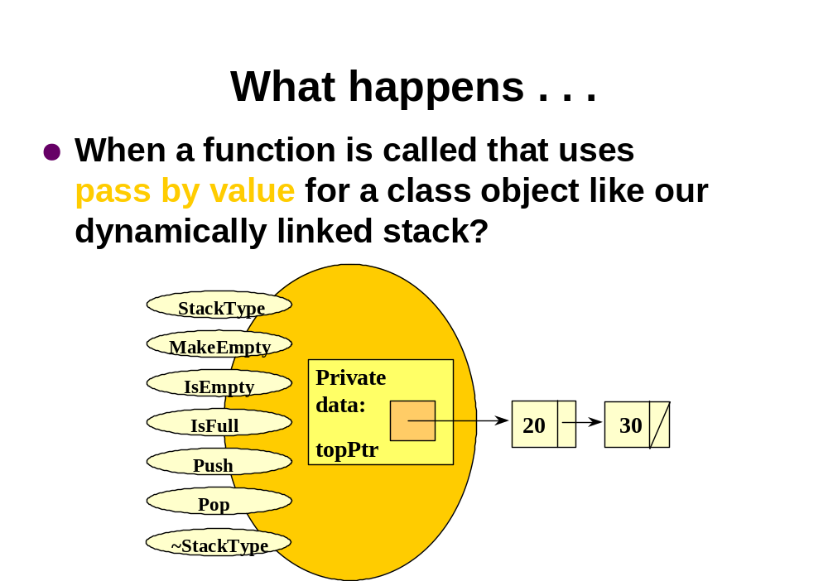
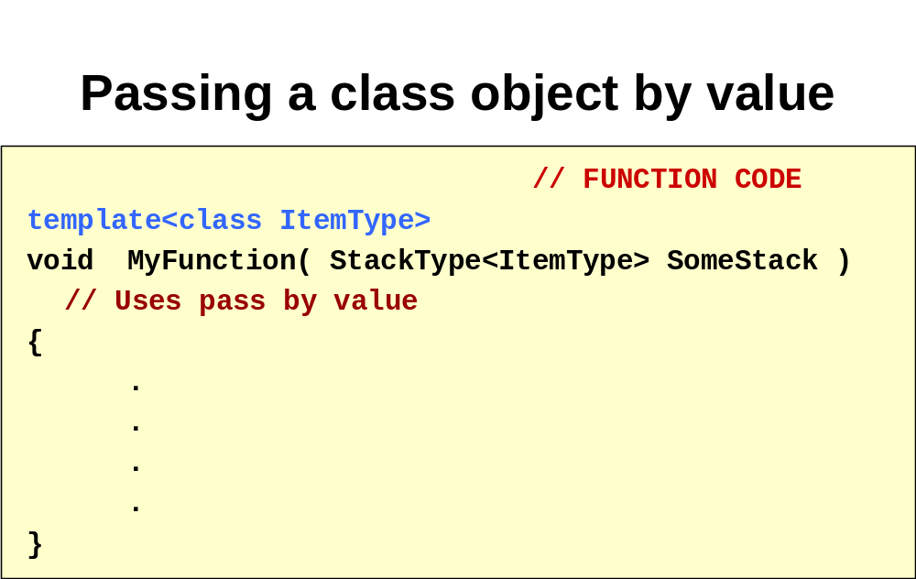
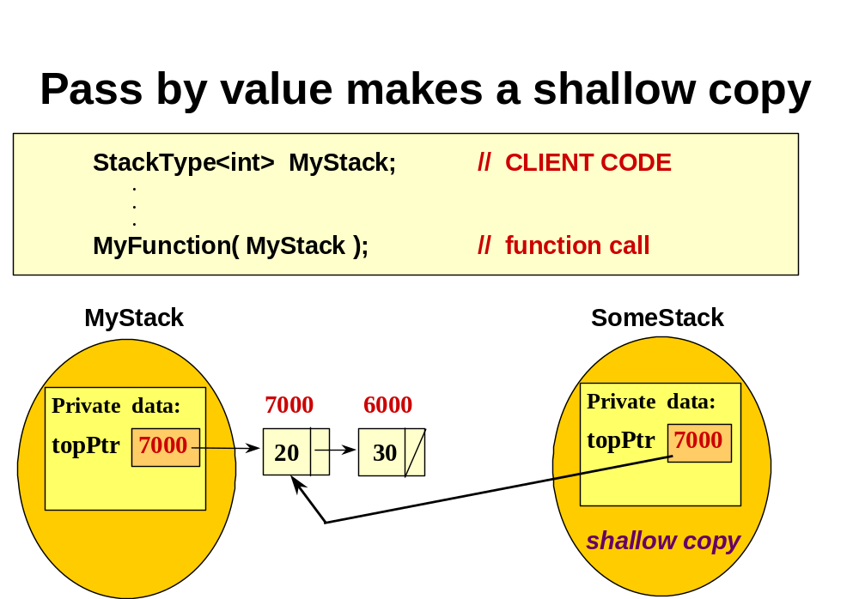
Shallow Copy vs. Deep Copy

- A shallow copy copies only the class data members, and does not copy any pointed-to data.

- A deep copy copies not only the class data members, but also makes separately stored copies of any pointed-to data.
What’s the difference?

- A shallow copy shares the pointed to data with the original class object.

- A deep copy stores its own copy of the pointed to data at different locations than the data in the original class object.
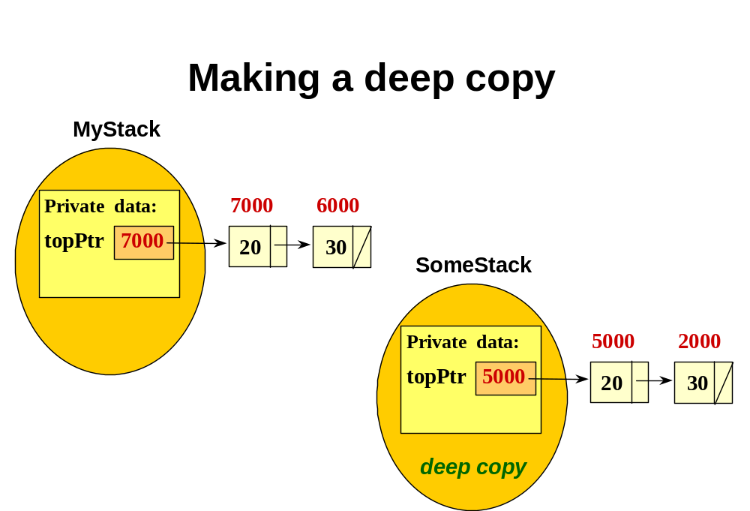
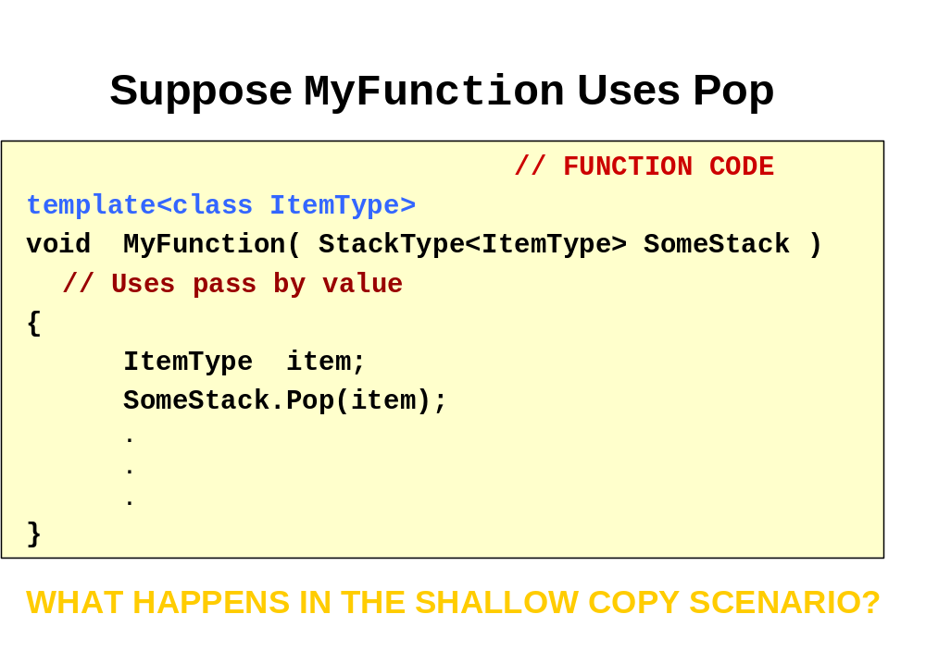
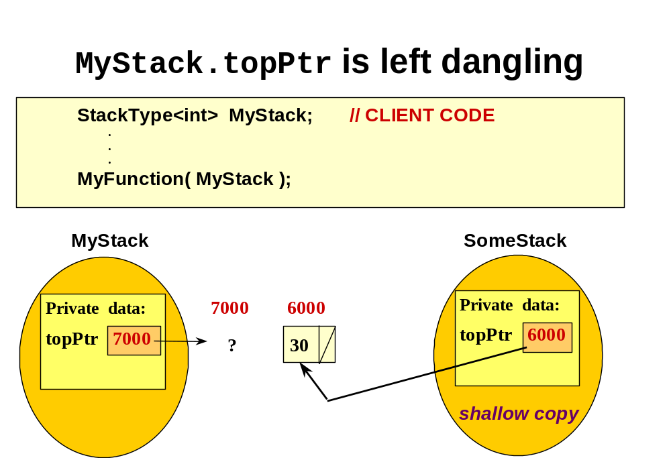
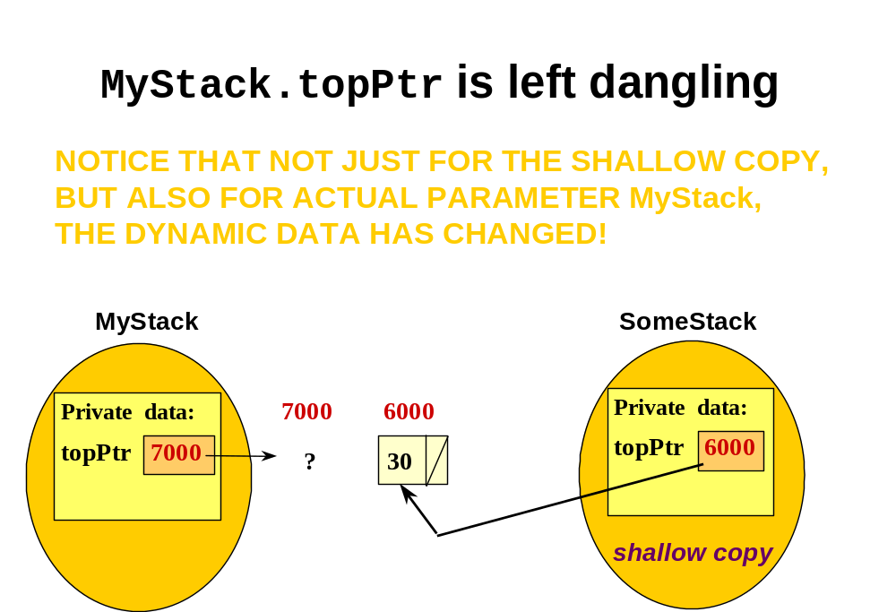
As a result . . .

- This default method used for pass by value is not the best way when a data member pointer points to dynamic data.

- Instead, you should write what is called a copy constructor, which makes a deep copy of the dynamic data in a different memory location.

More about copy constructors

- When there is a copy constructor provided for a class, the copy constructor is used to make copies for pass by value.

- You do not call the copy constructor.

- Like other constructors, it has no return type.

- Because the copy constructor properly defines pass by value for your class, it must use pass by reference in its definition.
Copy Constructor

- Copy constructor is a special member function of a class that is implicitly called in these three situations:
- passing object parameters by value,
- initializing an object variable in a declaration,
StackType<int> myStack = yourStack;
- returning an object as the return value of a function.
return thisStack;
// DYNAMICALLY LINKED IMPLEMENTATION OF STACK

template<class ItemType>
class StackType {
public:
StackType( );
// Default constructor.
// POST: Stack is created and empty.
StackType( const StackType<ItemType>& anotherStack );
// Copy constructor.
// Implicitly called for pass by value.

.
.
.
~StackType( );
// Destructor.
// POST: Memory for nodes has been deallocated.
private:
NodeType<ItemType>* topPtr ;
};
Template Struct of Node Element

template<class ItemType>
struct NodeType
{
ItemType info;

NodeType *next;
}

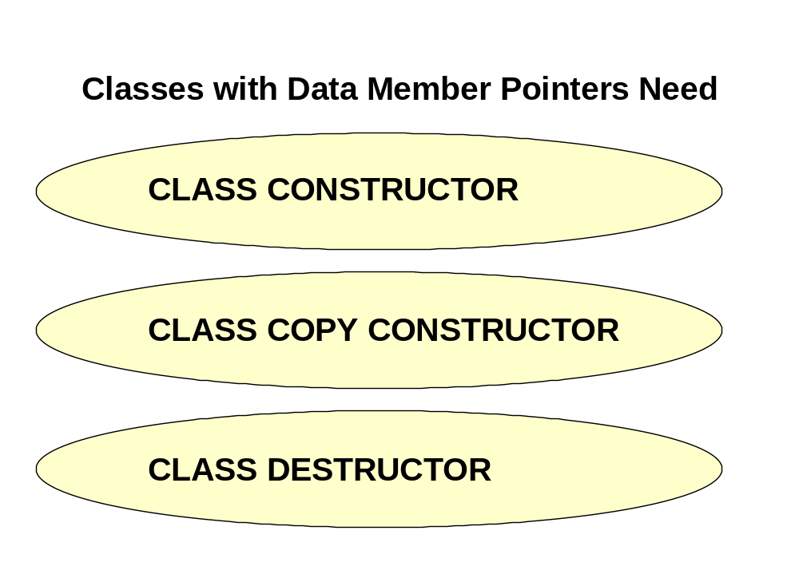
template<class ItemType> // COPY CONSTRUCTOR
StackType<ItemType>::
StackType( const StackType<ItemType>& anotherStack )
{ NodeType<ItemType>* ptr1 ;
NodeType<ItemType>* ptr2 ;
if ( anotherStack.topPtr == NULL )
topPtr = NULL ;
else // allocate memory for first node
{ topPtr = new NodeType<ItemType> ;
topPtr->info = anotherStack.topPtr->info ;
ptr1 = anotherStack.topPtr->next ;
ptr2 = topPtr ;
while ( ptr1 != NULL ) // deep copy other nodes
{ ptr2->next = new NodeType<ItemType> ;
ptr2 = ptr2->next ;
ptr2->info = ptr1->info ;
ptr1 = ptr1->next ;
}
ptr2->next = NULL ;
}
}
What about the assignment operator?

- The default method used for assignment of class objects makes a shallow copy.

- If your class has a data member pointer to dynamic data, you should write a member function to overload the assignment operator to make a deep copy of the dynamic data.

// DYNAMICALLY LINKED IMPLEMENTATION OF STACK

template<class ItemType>
class StackType {
public:
StackType( );
// Default constructor.
StackType( const StackType<ItemType>& anotherStack );
// Copy constructor.
void operator= ( StackType<ItemType> );
// Overloads assignment operator.

.
.
.

~StackType( );
// Destructor.
private:
NodeType<ItemType>* topPtr ;
};

Recall Definition of Queue

- Logical (or ADT) level: A queue is an ordered group of homogeneous items (elements), in which new elements are added at one end (the rear), and elements are removed from the other end (the front).

- A queue is a FIFO “first in, first out” structure.

Queue ADT Operations

- MakeEmpty -- Sets queue to an empty state.
- IsEmpty -- Determines whether the queue is currently empty.

- IsFull -- Determines whether the queue is currently full.
- Enqueue (ItemType newItem) -- Adds newItem to the rear of the queue.

- Dequeue (ItemType& item) -- Removes the item at the front of the queue and returns it in item.
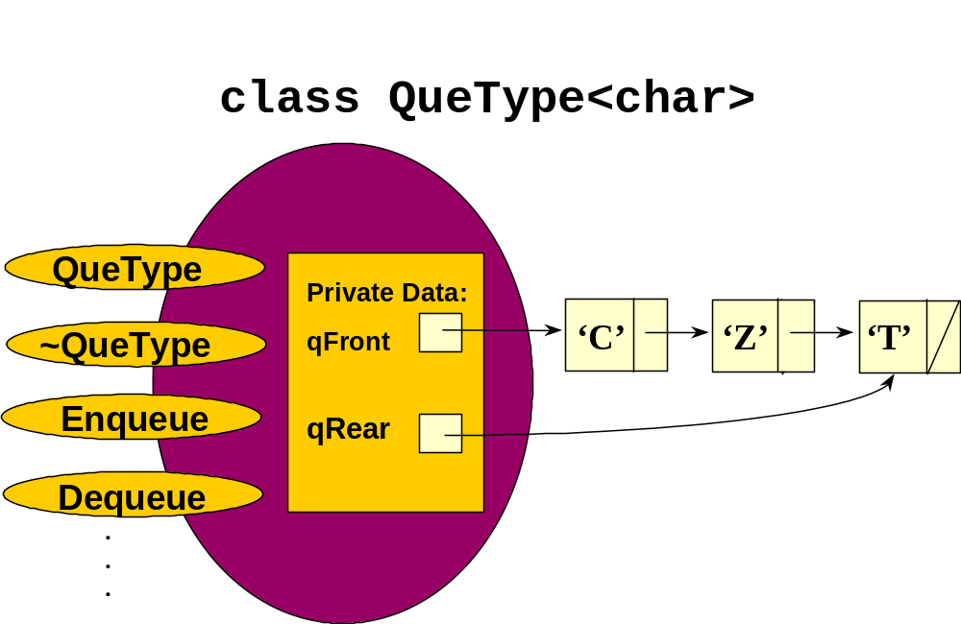
// DYNAMICALLY LINKED IMPLEMENTATION OF QUEUE

#include "ItemType.h" // for ItemType

template<class ItemType>
class QueType {
public:
QueType( ); // CONSTRUCTOR
~QueType( ) ; // DESTRUCTOR
bool IsEmpty( ) const;
bool IsFull( ) const;
void Enqueue( ItemType item );
void Dequeue( ItemType& item );
void MakeEmpty( );
private:
NodeType<ItemType>* qFront;
NodeType<ItemType>* qRear;
};

Functions Enqueue and Dequeue
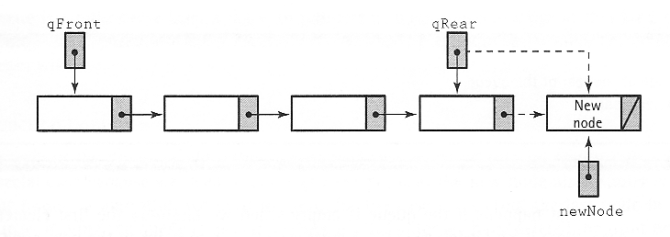
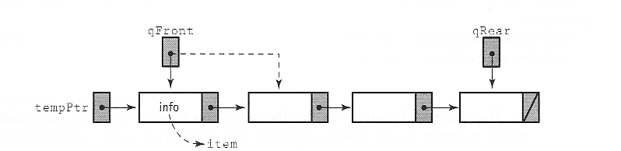

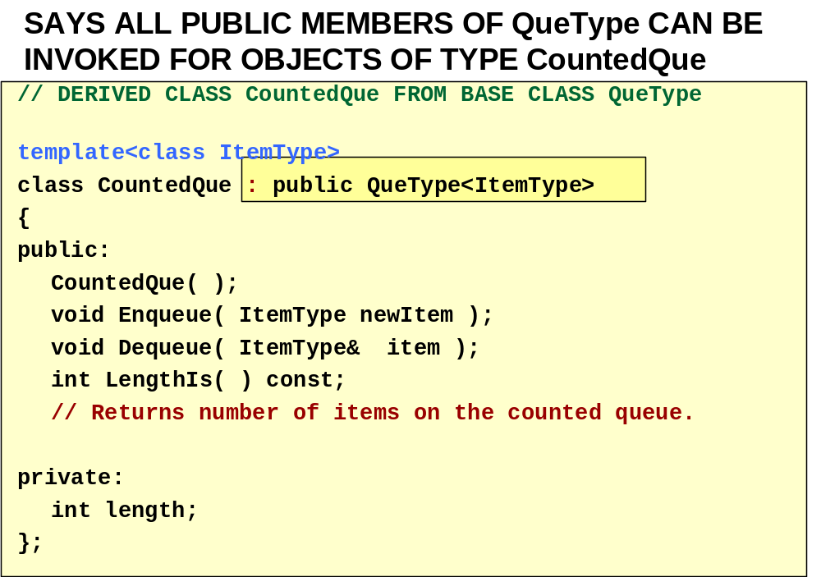
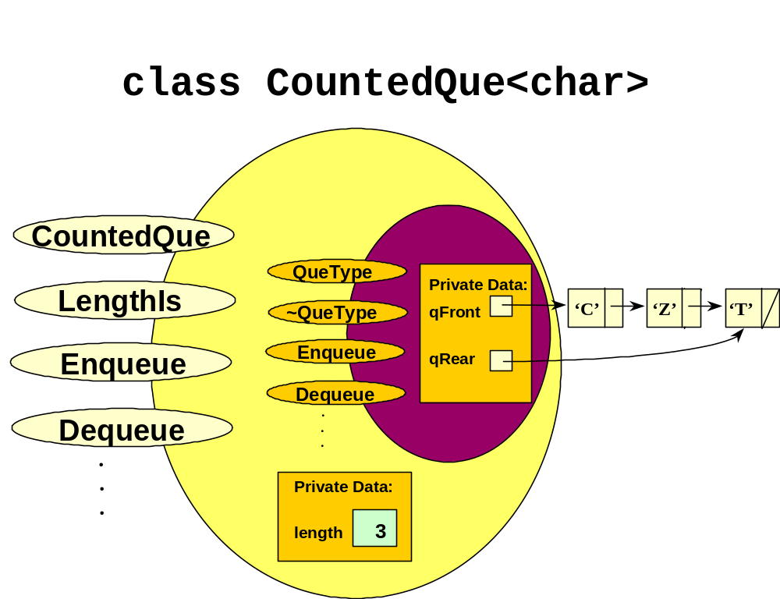
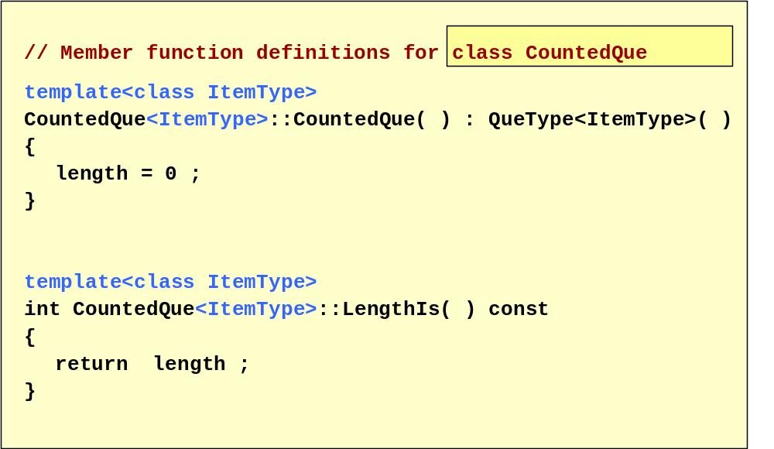
template<class ItemType>
void CountedQue<ItemType>::Enqueue( ItemType newItem )
// Adds newItem to the rear of the queue.
// Increments length.
{
length++;

QueType<ItemType>::Enqueue( newItem );
}

template<class ItemType>
void CountedQue<ItemType>::Dequeue(ItemType& item )
// Removes item from the rear of the queue.
// Decrements length.
{
length--;

QueType<ItemType>::Dequeue( item );
}

Today’s Lecture

- Stack & Queue by Linked Lists

Next Lecture

- Lists by Linked Lists

